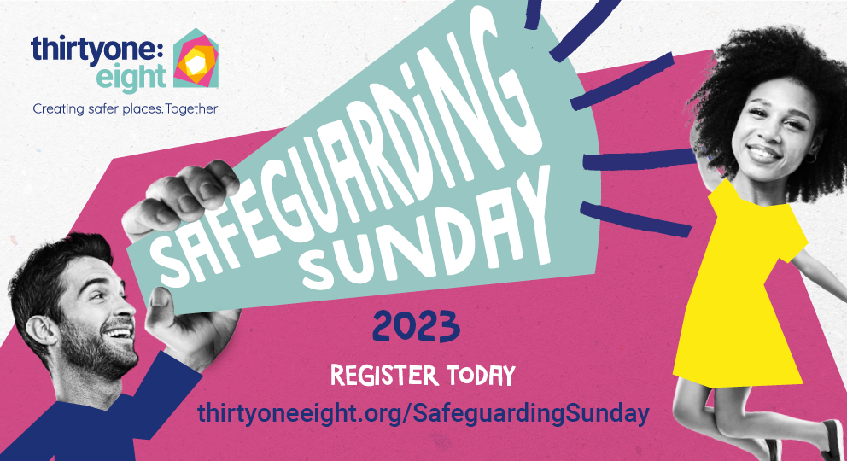

Safeguarding Sunday 2023 communications pack

Thank you for taking part in Safeguarding Sunday 2023 – we value your support and appreciate all you do to create safer places for vulnerable people in your church and community.

This communications pack is a toolkit to help you raise the profile of the campaign in your church, community and local media. It’s an opportunity to show your community that you take safeguarding seriously as an outworking of your faith in a just and loving God.

Will you help us tell a new story – one of hope in the face of ever-increasing revelations of abuse and trauma? Good news stories do exist, and you and your church are one of them! This is something to shout about. Will you help us make this year’s campaign bigger than ever before?

In this pack, you will find the following content and links:
- Press release template
- Church comms/newsletter content
- Social media post content
- Social media, website, and email graphics

Tips for getting local media coverage

- Find out who to contact in local newspapers, magazines and radio stations. Note the names of writers, editors and broadcasters who produce material this might be relevant for and ask what their deadlines are.

- Contact details for journalists can usually be found on a newspaper’s “contact us” page. You may want to send your material to a specific journalist who covers spiritual or religious issues, but you could also send it to the general news desk email address.

- Keep emails to journalists succinct. They are likely to be busy, so will be more likely to read your message if it is easily digestible. We have a press template below that you can send with your email. However, a couple of bullet points or short paragraph summarising it in the main body of the email will help the press contact to pick up the key details.

- If local journalists are particularly active on social media – especially Twitter – you could consider reaching out to them via your church’s social media accounts. Remember to use the hashtag #SafeguardingSunday.

- Include photos with your press release or letter to editor. If they include people, make sure to include their names and role, as well as checking you have their permission to use the photo. You can also use one of our social media images linked to below.

- Give journalists contact details for the relevant contact at your church about your involvement in the campaign. If they have questions or want to know more about your church, this will make it easy for them to follow up.

- If you don’t get a response to an email, try phoning instead. Journalists are inundated with information, so a call might help you not to get lost in the noise.

- Press release template

HEADER: [Name of church] joins thousands of churches across the UK to say yes to safeguarding and no to abuse.

[Body content]
[Name of church] will join thousands of other churches across the UK to highlight the importance of protecting vulnerable people as part of Safeguarding Sunday, an awareness-raising national campaign organised by Christian safeguarding charity Thirtyone:eight.

This year’s Safeguarding Sunday campaign takes place on Sunday 19 November, coinciding with the start of Safeguarding Adults Week (20–24 November).

Last year, more than 3,000 churches took part in the event, with this year looking to be bigger than ever. Having taken part in the campaign, churches reported:
- greater positive awareness and understanding of safeguarding among church members
- an increase in the number of people feeling able to talk about their abuse for the first time
- more volunteers coming forward for safeguarding roles and to help with children’s and youth work
- an increased number of people completing safeguarding training and criminal record checks
- a greater number of Safeguarding Leads feeling supported in their role by the church.

Children from [Name of church] will have the chance to explore with their church workers what to do when they feel worried or upset, and the importance of speaking up.

Church workers can register at thirtyoneeight.org/SafeguardingSunday and download a free resource pack to help them plan the event, including a range of activities for children to help them understand that their voice matters and will be heard. Lesson plans will be brought to life by the colourful character, Roarry the lion, with children being encouraged to ‘raise their roar’ if they feel unsafe or are worried about someone.

Justin Humphreys, Joint Chief Executive at Thirtyone:eight, said:
“While we can’t and shouldn’t ignore abuse that has happened within the Church, of which there has been plenty of media coverage, Safeguarding Sunday is a chance to shine a light on what so many churches are doing to make places of worship safer. We mustn’t forget that protecting vulnerable people is at the heart of the Christian message of justice and hope. I want to thank everyone who is doing this vital ongoing work and taking part in this year’s campaign to raise awareness of the importance of safeguarding in their church and community.”

For more information on Safeguarding Sunday visit thirtyoneeight.org/get-involved/safeguarding-sunday

[ENDS]

Interviews available on request.

Notes to editors:
- Thirtyone:eight is the leading independent Christian safeguarding charity in the UK.
- Thirtyone:eight works with a network of faith and non-faith based charities and organisation across the country, to help support, train and equip their workers and volunteers to effectively safeguard children and adults at risk.
- Thirtyone:eight works in partnership with government and statutory agencies, as well as leaders from across church denominations to embed best practice.
- Thirtyone:eight does this by providing professional advice, support, training and resources in all areas of safeguarding and child protection for children, adults and for those affected by abuse.
- Thirtyone:eight is not affiliated to any single church denomination or tradition.
- Thirtyone:eight is a partner agency with CEOP (the Child Exploitation and Online Protection centre), members of the government National Working Group on Child Abuse Linked to Faith or Belief, and associate members of the UK Council for Child Internet Safety (UKCCIS).

For more information about the campaign, please contact Emma Lawson, Communications Manager at Thirtyone:eight on 0303 003 11 11 ext 2706 or emma.lawson@thirtyoneeight.org

- Church communications/newsletter content

These are lines to take and personalise to your congregation.

- Safeguarding Sunday, an awareness-raising campaign organised by Christian safeguarding charity Thirtyone:eight, is taking place on 20 November 2022.
- [Name of church] is taking part to highlight the importance of creating safer places for all.
- We will be joining thousands of other churches across the UK to share this message and demonstrate unity.
- We also want to take this opportunity to thank and pray for those who have stepped up to coordinate safeguarding in our church so we can protect vulnerable people together.
- We believe that safeguarding is an outworking of our faith in a loving and just God – the God who calls us to speak up on behalf of those who cannot speak for themselves and to defend the rights of the vulnerable (Proverbs 31:8).
- Justice and hope are at the heart of the Christian message. Let’s gather and celebrate those who work behind the scenes to protect vulnerable people and make our church a safer place for all.
- We will be using resources provided by Thirtyone:eight in our service and in our children’s groups. These will be age-appropriate and inclusive, using language that children can understand to explore safeguarding issues safely. Please contact [Name of Safeguarding Lead or appropriate person in your church] for more information or if you’d like to see the activity materials beforehand.
- We’d love to share a few #SafeguardingSunday snaps for our social media channels so that Thirtyone:eight and all our followers can see what we’ve been doing to celebrate this important day and raise awareness. If you’d prefer not to be in any photos, or if you have a child/children in a group and do not want them to be in any photos, please let [Name of Safeguarding Coordinator or appropriate person in your church] know.

- Social media post content

3 weeks to go before #SafeguardingSunday, a campaign organised by @thirtyoneeight. Our church is committed to protecting vulnerable people and creating safer places for all, which is what this campaign is all about. Join us on Sunday 19 November to find out more!
Link: thirtyoneeight.org/get-involved/safeguarding-sunday

2 weeks to go before #SafeguardingSunday, an opportunity to thank those who work hard to make our church a safer place for all. @thirtyoneeight have provided resources to guide our service and all-age activities so everyone can learn what to do if they feel unsafe! Join us this Sunday.
Link: thirtyoneeight.org/get-involved/safeguarding-sunday

1 week to go before #SafeguardingSunday! God cares about protecting vulnerable people, and so do we. Share your snaps of the day using the hashtag #SafeguardingSunday and don’t forget to mention @thirtyoneeight so they can see all of what we’ve been up to! (Please ensure you have permission to share.)
Link: thirtyoneeight.org/get-involved/safeguarding-sunday

- Social media, website, and email graphics

Download > Facebook image – register
Download > Facebook image – 3 weeks to go
Download > Facebook image – 2 weeks to go
Download > Facebook image – 1 week to go

Download > Instagram, LinkedIn and Twitter image – register
Download > Instagram, LinkedIn and Twitter image – 3 weeks to go
Download > Instagram, LinkedIn and Twitter image – 2 weeks to go
Download > Instagram, LinkedIn and Twitter image – 1 week to go

Download > Website hero banner
Download > Website image – register
Download > Website image – 3 weeks to go
Download > Website image – 2 weeks to go
Download > Website image – 1 week to go

Download > Email banner image – register
Download > Email image – 3 weeks to go
Download > Email image – 2 weeks to go
Download > Email image – 1 week to go

